Darke County Fair Department of Fine Arts Presents

2024 Onsite PHotography Competition

twO-day judged contest

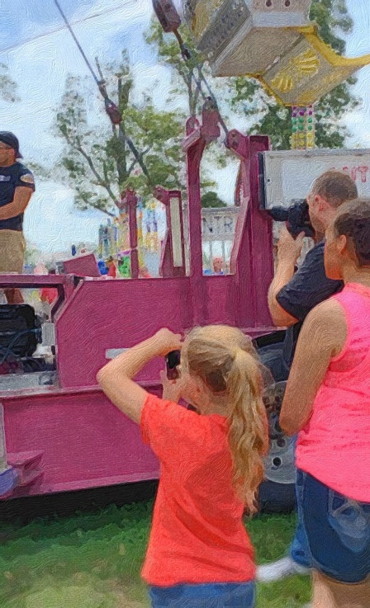

Saturday, August 17-Sunday August 18, 2024

Pre-Registration: Friday, August 16, 2024 10:00 AM-10:00 PM- Fine Arts Building

Saturday, August 17, 2024 10:00 AM-3:00 PM-Fine Arts Building

Bring your photography supplies, creativity and enthusiasm to capture the essence and spirit of The Great Darke County Fair!
  - Grand Prize: $100
2nd Place-$50.00 3rd Place-$25.00 Honorable Mention- Ribbon
Competition Rules & Itinerary:
- Professional and amateur photographers welcomed.
- Open to all photographers 14 and over.
- You may submit up to three photographs for judging.
- Photograph size must be 8” x 10” (Frame may be any size).
- You must bring all your own photography supplies: Whatever makes you feel confident.
- No person may begin before 3:30 PM, Saturday, August 17, 2024.
- No person may submit final pieces after 3:00 PM, Sunday, August 18, 2024.
- As a photographer, it is your responsibility to request permission to shoot and submit photographs of minors. You will be supplied with identification that you are participating in our photography competition and copies of the waiver that needs to be signed by the guardian of the minor(s). If your submitted photo contains minors, the release(s) must be attached to the back of the photo when submitted or it will not be accepted. I realize this may be challenging until you get the hang of it, but we must practice safety first.
- Topic subject selection for the shoot off will be released in the Fine Arts Building Saturday, August 17, 2024 at 3:30 PM!
- Printing may be done wherever you choose.
- Submitted entry must be suitably presented in a frame with a wired back for proper hanging. (They will hang in the building all week.)
- Submitted entries must remain on display during the exhibition period, August 17-24, 2024.
- Pickup August 25, 2024.
- We reserve the right to disqualify works deemed in poor taste.
Registration:
- Friday, August 16, 2024 10:00 AM-10:00 PM- Fine Arts Building
- Saturday, August 17, 2024 10:00 AM-3:00 PM-Fine Arts Building
- $10 per individual.
- Fees are non-refundable.

Entrants are encouraged to visit the fair prior to contest day to check lighting and such!
Judging: Closed Judging Sunday, August 18, 2024 3:30 PM
Awards: Awards presented Sunday, August 18, 2024- 4:00 PM- Fine Arts Building

Grand Prize- $100.00
2nd Place- $50.00
3rd Place- $25.00
Honorable Mention- Ribbon

