Department of Arts
Class M- Fine Arts Division
www.fineartsprogram.com
Christoph Keller, Superintendent
Amanda Mote, Secretary
mote_amanda@yahoo.com
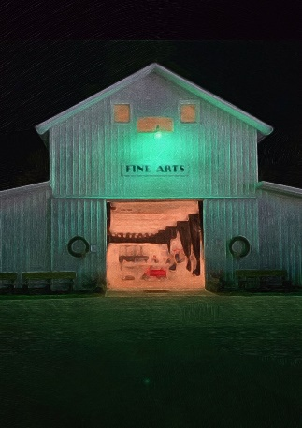
Important Dates:
All entries may be pre-registered online starting June 1, 2024
Entry Delivery- Friday, August 9, 2024, 1:00 p.m.-6 p.m.
Entry Delivery -Saturday, August 10, 2024, 12:00 p.m.-5 p.m.
Opening Reception/Awards (reserved for exhibitors)-Wednesday, August 14, 2024, 6:00 p.m.-8:00 p.m.
Daily Exhibition hours -Friday, August 16- August 24, 2024, 10:00 a.m.-10:00 p.m.
Entry Pickup -Sunday, August 25, 2024, 1:00 p.m.-4:00 p.m.

Fine Arts Best of Show Award
Photography Best of Show Award
Darke County Pride Award
People’s Choice Award-Fine Arts
People’s Choice Award-Photography
The Francesca Shellabarger Award
The Superintendents Award

General Information and Guidelines:
Amateur- Individual over the age of 18 who does artwork/photography as a leisurely hobby, that is unprofessional and unpaid. If you sell your work, please enter the professional division. May compete as a professional, if so desired.
Professional- Individual that is an expert or specialized, having received gratuity for completed work. This includes work sold online. No professional may compete as an amateur.
Individuals with different abilities- Individual with a physical or mental disability that makes them different, not less.
- Fees: All exhibitors must present or purchase their week-long fair pass upon entry admissions. These will also be available during the check-in process at a cost of $25. Fair passes are also available online at www.darkecountyfair.com. Fees will not be refunded for cancelled/non-exhibiting entries.
- Entry Requirements: REMINDER: ALL entries must be pre-registered online at www.darkecountyfair.com. If you are unable to complete this beforehand, we are happy to help at entry check in! All entries must be original, free of copyright and must not have been shown at the Darke County Fair in previous years. The Fair Committee reserves the right to disqualify and remove any entries not complying with these rules, or those that have been deemed untasteful. Pottery/Sculpture must be hand thrown or molded. Jewelry must be completely produced by the artist, with the exception of chains and hardware. Photography must not be smaller than 8”x10” or 36” around, or larger than 20”x24” or 88” around. No photograph of any minor may be used without the written consent of a legal guardian. All art and photography must comply with the display guidelines set below.
- Nudity: No nipples, cracks or private parts may be visible. This applies to both art and photography. Subtle and tasteful showing of skin will be accepted, however, there will be a very firm policy on this. Please remember this as you register your children, as well as when you prepare to visit the arts building. Reminder: No photograph of any minor may be used without the written consent of a legal guardian!
- Entry Limits: Fine Arts, professional and amateur adults (categories 1-20) may exhibit four (4) entries. Our Artist with different abilities and Children, Categories 21-73, may exhibit three (3) entries. Photography exhibitors, Categories 74-107, may exhibit three (3) entries. All exhibitors may enter the max amount of entries in both Fine Arts and Photography.
- Display: For protection, all hanging entries must be behind glass/plexiglass, with the exception of oil, acrylic and mixed media entries. Hanging mixed media must be on a gallery wrapped canvas. All aqua media and drawing must be behind glass. Gallery wraps may be submitted unframed, but whenever possible, framing is recommended and requested. A secure wire hanger attached to the back that is non-visible upon placement is required (see wire guide on following page). Works should be matted as it adds to the presentation factor. All 3-Dimensional work will be placed behind glass. Please make sure your name, address and telephone number are firmly attached to the lower, left corner on the BACK of your work. This will allow for a less painful check in procedure. To maintain a proper and fair judging process, the artists name must not be visible on items during the judging process. For those of you that have signed your work, removable cover ups will be put in place at take-in. These will be removed post judgement. We are not responsible for damaged work.
- Judging: Professional, guest judges will be selected each year, engaging in a closed judging. All judge decisions are final.
- Opening Reception/Awards: (REMINDER: Must have fair pass to attend) The Opening Reception & Awards Ceremony is an event specifically reserved for exhibitors and immediate family. During this time, awards will be announced, and winning exhibitors will be recognized. Light snacks and beverages available. Attire will be casual!
- Pricing: After judging has taken place, professionals are encouraged to place their business cards containing exhibitor contact information and selling price on entries. This allows for a private transaction to take place between artist and customers. No sales will take place per The Darke County Fair.
- Pickup: All premiums will be awarded upon pickup. All exhibits and awards must be signed out. Any exhibits not picked up during the designated timeframe become property of the Darke County Fair. We will not meet outside of the designated pickup times to return your pieces. If your piece is left behind all premium winnings will be voided. Please pick up your pieces on time!! It has been a major issue the past few years.
- Disputes: Disputes may be submitted in writing to mote_amanda@yahoo.com and will be reviewed within 48 hours.
Proper Anchor & Wire Placement
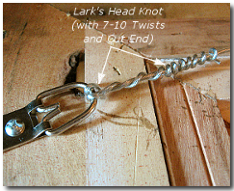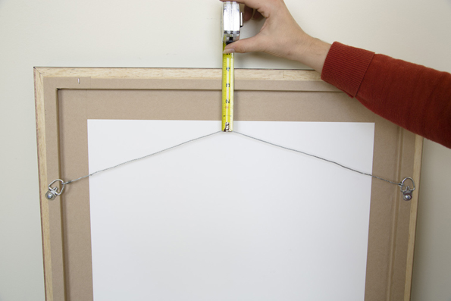
Fine Arts 2024
Fine Arts- Professional Adult
Awards: 1^{st-} $20 2nd- $15 3rd- $10
- Oil
- Acrylic, Tempera
- Aqua Media (Watercolor, Gouache, Alcohol Inks)
- Drawing (Pastel, Pen & Ink, Charcoal, Pencil, Colored Pencil)
- Mixed Media (Collage, Batik, etc.)
- Sculpture
- Ceramics/Pottery (Wheel-thrown or hand built)
- Jewelry (No Kits)
- Stained Glass
- Woodcarving, Woodworking (no larger than 12”x12”)
Fine Arts- Amateur Adults
Awards: 1^{st-} $10 2nd- $7 3rd- $5
- Oil
- Acrylic, Tempera
- Aqua Media (Watercolor, Gouache, Alcohol Inks)
- Drawing (Pastel, Pen & Ink, Charcoal, Pencil, Colored Pencil)
- Mixed Media (Collage, Batik, etc.)
- Sculpture
- Ceramics/Pottery (Wheel-thrown or hand built)
- Jewelry (No Kits)
- Stained Glass
- Woodcarving, Woodworking (no larger than 12”x12”)
Fine Arts- Adults with Different Abilities
Awards: 1^{st-} $10 2nd- $7 3rd- $5
- Oil
- Acrylic, Tempera
- Aqua Media (Watercolor, Gouache, Alcohol Inks)
- Drawing (Pastel, Pen & Ink, Charcoal, Pencil, Colored Pencil)
- Mixed Media (Collage, Batik, etc.)
- Sculpture
- Ceramics/Pottery (Wheel-thrown or hand built)
- Jewelry (No Kits)
- Stained Glass
- Woodcarving, Woodworking (no larger than 12”x12”)

Fine Arts- Children with Different Abilities (10-17)
Awards: 1^{st-} $5 2nd- $4 3rd- $3
- Oil
- Acrylic/ Tempera
- Aqua Media (Watercolor, Gouache, Alcohol Inks)
- Drawing (Pastel, Pen & Ink, Charcoal, Pencil, Colored Pencil)
- Mixed Media (Collage, Batik, etc.)
- Sculpture
- Ceramics/Pottery (Wheel-thrown or hand built)
- Jewelry
Fine Arts- Children with Different Abilities (0-10)
Awards: 1^{st-} $5 2nd- $4 3rd- $3
- Painting
- Drawing
- Mixed Media
Fine Arts- Senior High School (Grades 9-12)
Awards: 1^{st-} $10 2nd- $7 3rd- $5
- Oil
- Watercolor
- Acrylic/Tempera
- Pastel
- Drawing (Pen & Ink, Charcoal, Pencil, Colored Pencil)
- Mixed Media (Collage, Batik, etc.)
- Ceramics/Pottery (Wheel-thrown or hand built)
- Sculpture
Fine Arts- Middle School (Grades 5-8)
Awards: 1^{st-} $10 2nd- $7 3rd- $5
- Oil
- Watercolor
- Acrylic/Tempera
- Pastel
- Drawing (Pen & Ink, Charcoal, Pencil, Colored Pencil)
- Mixed Media (Collage, Batik, etc.)
- Ceramics/Pottery (Wheel-thrown or hand built)
- Sculpture

Fine Arts- Elementary (Grades 1-4)
Awards: 1^{st-} $10 2nd- $7 3rd- $5

- Mixed Medias
- Watercolor
- Acrylic/Tempera
- Pastel/Chalk
- Drawing
- Crayon/ Marker
- Pottery
- Sculpture

Fine Arts- Children (0-Kindergarten)
Awards: 1^{st-} $10 2nd- $7 3rd- $5
- Mixed Media
- Watercolor
- Acrylic/ Tempera
- Pastel/ Chalk
- Drawing/ Color Pencils
- Crayons/ Marker
- Pottery
- Sculpture

Photography 2024
Photography-Professional Adults
Color:
Awards: 1^{st-} $20 2nd- $15 3rd- $10
- People (Candids, Action Shots, human interests)
- Picturesque (Broadview, Landscapes, Waterscapes, Cityscapes)
- Skyscapes (Sunrises, Sunsets, Stormy Skies, Cloud Formations, Rainbows)
- Botanicals (Flowers, Plants, Trees, etc.)
- Animals (Wildlife and Domestic Animals, includes insects, birds, fish, etc. No humans)
- Unclassified/ Miscellaneous
Black & White:
Awards: 1^{st-} $20 2nd- $15 3rd- $10
- People (Candids, Action Shots, human interests)
- Picturesque (Broadview, Landscapes, Waterscapes, Cityscapes)
- Skyscapes (Sunrises, Sunsets, Stormy Skies, Cloud Formations, Rainbows)
- Botanicals (Flowers, Plants, Trees, etc.)
- Animals (Wildlife and Domestic Animals, includes insects, birds, fish, etc. No humans)
- Unclassified/ Miscellaneous
Photography- Amateur Adults
Color Photography:
Awards: 1^{st-} $10 2nd- $7 3rd- $5
- People (Candids, Action Shots, human interests)
- Picturesque (Broadview, Landscapes, Waterscapes, Cityscapes)
- Skyscapes (Sunrises, Sunsets, Stormy Skies, Cloud Formations, Rainbows)
- Botanicals (Flowers, Plants, Trees, etc.)
- Animals (Wildlife and Domestic Animals, includes insects, birds, fish, etc. No humans)
- Unclassified/ Miscellaneous
Black & White Photography:
Awards: 1^{st-} $10 2nd- $7 3rd- $5
- People (Candids, Action Shots, human interests)
- Picturesque (Broadview, Landscapes, Waterscapes, Cityscapes)
- Skyscapes (Sunrises, Sunsets, Stormy Skies, Cloud Formations, Rainbows)
- Botanicals (Flowers, Plants, Trees, etc.)
- Animals (Wildlife and Domestic Animals, includes insects, birds, fish, etc. No humans)
- Unclassified/ Miscellaneous

Photography- Individuals with Different Abilities
Adults with Different Abilities:
Awards: 1^{st-} $10 2nd- $7 3rd- $5
- Black & White Photography
- Color Photography
Children with Different Abilities (0-17)
Awards: 1^{st-} $5 2nd- $4 3rd- $3
- Black & White Photography
- Color Photography
Youth Photography:
Senior High (Grades 9-12)
Awards: 1^{st-} $5 2nd- $4 3rd- $3
- Black & White Photography
- Color Photography
Middle School (Grades 5-8)
Awards: 1^{st-} $5 2nd- $4 3rd- $3

- Black & White Photography
- Color Photography
Elementary (Grades K-4)
Awards: 1^{st-} $5 2nd- $4 3rd- $3
- Black & White Photography
- Color Photography

“To keep things fresh!”

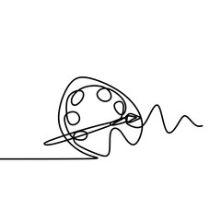
2024 Fine Arts Specialty Categories & Challenges
2-Dimensional Only
All ages, regardless of status, may participate in these categories:
Awards: 1^{st-} $25 2nd- $15 3rd- $10

- Essence of a Dream
- Flowers
- Sunsets & Sunrises
- Charicatures
- A page from your favorite Story Book

2024 Photography Specialty Categories & Challenges
All ages, regardless of status, may participate in these categories:
Awards: 1^{st-} $25 2nd- $15 3rd- $10

- So God made a Farmer
- Sister, Sister
- Historical Landmarks (label location)
- Genorations
- Authentic Joy

