Darke County Fair Department of Fine Arts Presents

2024 Plein Air Competition

one-day judged contest

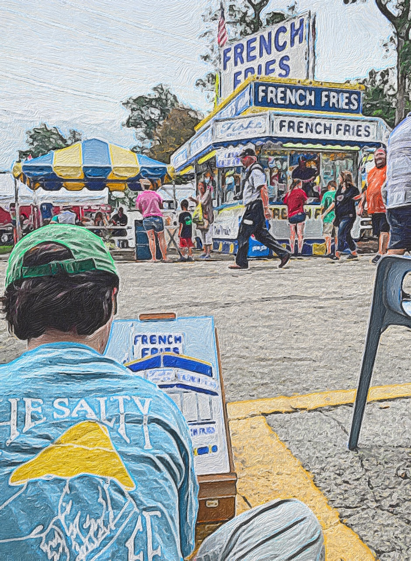

Saturday, August 17, 2024 11:00 AM-5:00 PM

Pre-Registration: Friday, August 16, 2024 10:00 AM-10:00 PM- Fine Arts Building

Check-in: Saturday, August 17, 2024 10:00 AM-11:00 AM- Fine Arts Building

Bring your personal art supplies and talent to capture the essence and spirit of The Great Darke County Fair!
  - Grand Prize: $100
2nd Place-$50.00 3rd Place-$25.00 Honorable Mention- Ribbon

  - Competition Rules:

- Any painting/drawing media may enter.
- Open to all artist 14 and over.
- You may bring up to three blank canvases, paper or other surfaces to create on.
- Max surface size is 16” x 20”.
- Surfaces must be blank and cannot have any prior sketches or markings.
- No working from photographs.
- Your work surface will be stamped upon check-in by fair staff.
- You must bring all your own art supplies: Easel, paints, brushes, etc.
- Only one artwork per entrant can be submitted into the contest for judging.
- No person may begin before 11:00 AM, August 17, 2024.
- No person may submit final pieces after 5:00 PM, August 17, 2024.
- Submitted entry must be suitably presented with a wire on the back for proper hanging.
- Submitted entry must be unsigned for judging.
- Submitted entries must remain on view during the exhibition period, August 17-24, 2024.
- Pickup August 25, 2024.
- We reserve the right to disqualify works deemed in poor taste.

Registration:

- Pre-Register Friday, August 16, 2024 10:00AM-10:00PM; Aug 17, 2024 9:00AM-11:00PM -Fine Arts Building.
- $10 per individual.
- Fees are non-refundable.

Entrants are encouraged to visit the fair prior to contest day to choose a subject area. However, no photos or sketches of the subject will be allowed on contest day.

Judging:
- Closed Judging Saturday, August 17, 2024- 5:30 PM

Awards:
- Awards presented Saturday, August 17, 2024- 6:00 PM- Fine Arts Building

Grand Prize- $100.00
2nd Place- $50.00
3rd Place- $25.00
Honorable Mention- Ribbon

