Darke County Fair Department of Fine Arts Presents
Painting with Friends

You asked and we listened!
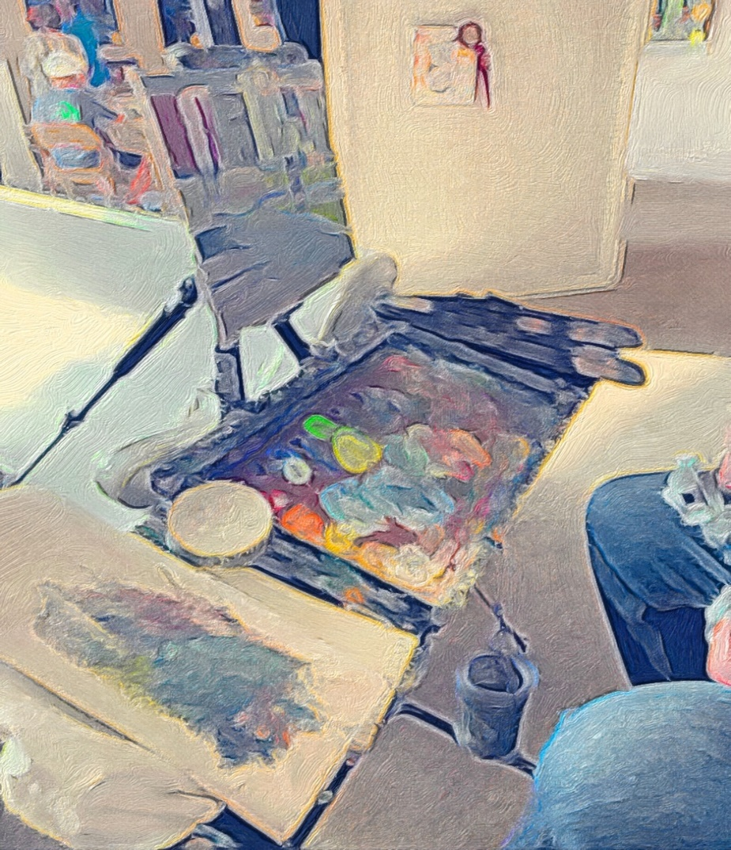

Wednesday, August 21,2024 2:00 PM-5:00 PM

Bring your supplies and join us to create, socialize and make a new friend at The Community Table located in the front of the Fine Arts Building!

